STANDARD OPERATING PROCEDURE
Use this form to document the Health and Safety information associated with the procedure.

Procedure Title |  | Culturing bacterial isolates from glycerol stocks on plates
Dept | ABE |  |  | Bldg/Rm | 4210 Sukup |  | Supervisor | Adina Howe

Procedure Overview:

This SOP is written for plating Syncom13 bacterial isolates. It was developed for Syncom13 but can be modified for other isolates which are plated from glycerol stocks.

Health and safety information for materials used (briefly describe the hazards associated with the materials and/or equipment OR document your hazard assessment in Section I)

Exposure to freezing items – frostbite potential
Exposure to bacteria isolated from the environment – pathogenicity uncharacterized. Work in biosafety cabinet.

Hazard Control Measures
Please select which type of lab coat, eye protection, and hand protection will be used (Lab coat, eye and hand protection, and closed toe/heel shoes must be selected as required by Section D of the ISU Laboratory Safety Manual.)
 | Latex gloves |  | Insulated gloves |  | Face shield |  | Respirator
 | Nitrile gloves |  | Safety glasses |  | Lab coat |  | Fume hood
 | Neoprene gloves |  | Vented goggles |  | Apron |  | Biosafety cabinet
 | Vinyl gloves |  | Splash goggles |  | Dust mask |  | Glove box
 | Fully enclosed shoes |  |  |  | Flame resistant lab coat

Other Control Measures
A biosafety cabinet prevents the cultures from becoming contaminated. Work under aseptic conditions.

Methods (Include step by step instructions detailing the process or attach this document to an existing method.)

Biosafety Cabinet Preparation

(Work should be completed in the biosafety cabinet.)

1. Set sash height to the line that is labeled sash height.

2. Ensure sterile environment by cleaning surfaces in the biosafety cabinet with 70% ethanol before use and place each material in the biosafety cabinet after surface sterilizing with ethanol. Set up your work progression in the cabinet from clean to “dirty”.

3. Place waste bin in biosafety cabinet to dispose of used loops.

Glycerol Stock Handling

1. Glycerol stocks can be obtained from a -80°C freezer and are generally contained in cryo-vials, often with orange lids. Vials must be kept as close to -80°C as possible so only remove 1-2 glycerol stocks to work with at a time.

2. Place glycerol stocks in an ice bath once out of the freezer to ensure they do not thaw which can damage the viability of the stock (Ice bucket can be found in the GERMS lab and the ice is in the autoclave room).

3. Place tube in -80°C freezer immediately after you are done with the glycerol stock and use a sharpie ti mark a line on the side of the lid. Once a glycerol stock has 5 lines, no longer use that stock, and move on to another glycerol stock of the same isolate without 5 lines.

Materials
- Disposable Loops
- Waste Bin
- Plates with appropriate media
- Isolate Sample
- Sharpie (labeling)
- Ice
- Ice Bucket
- 70% Ethanol Spray

Streaking Procedure

- Label plate before beginning to streak.
  - Label should be put on the bottom of the plate not the lid. Include isolate name, date, and your initials.

- Using a disposable loop scrape a portion of the isolate from the glycerol stock using the larger end of the loop. Then take the side of the loop that touched the isolate and streak a quadrant starting by the label. See part A of the diagram below.

- Next flip to the other side of the large loop and streak a second quadrant touching the original streak 1-3 times. Repeat by going into the previous quadrant made touching the previous quadrant 1-3 times. See parts B-D of the diagram below
  - Note, if you would like you can use a new disposable loop for each quadrant.

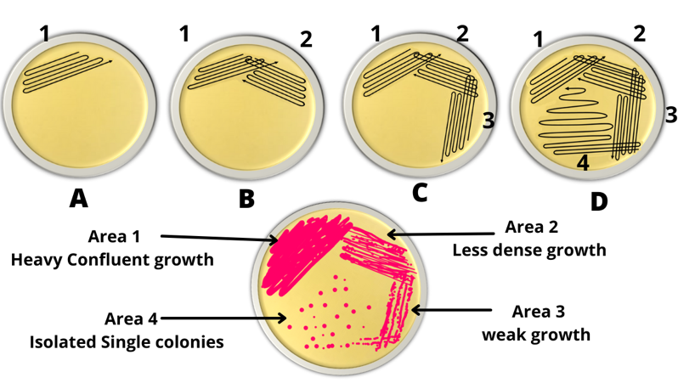

Incubation
- Once plated, take plates to the incubator and incubate them at 29°C, or the appropriate temperature for that organism.

2. Each Isolate has their own ideal incubation time. Check growth at regular intervals. See Shade Isolate Growth Schedule at 29°C below.

Clean Up
- After all plates have been streaked and placed in the incubator. Remove items from the biosafety cabinet. Place waste in the biohazardous waste container. Sterilize the waste bin for loops with 70% ethanol before removing from the cabinet.

- Wipe down biosafety cabinet with ethanol and wash the waste bin used to hold the used disposable loops.

- Close biosafety cabinet sash when done.

- Empty the ice from the bucket into the deep sink in the lab. Position the bucket so the interior can dry before being put away.

5. Dispose of your gloves in the biohazardous waste container. Wash hands thoroughly before next task.

Shade Isolate Growth Schedule at 29 C

Isolate | Treatment | Plate Incubation (Days) | Broth Incubation (Days)
PvR021 | SynCom13 | 1 | 1
PvR045 | SynCom13 | 1 | 1
PvR061 | SynCom13 | 1 | 1
PvR079 | SynCom13 | 2 | 1
PvR083 | SynCom13 | 1 | 1
PvR090 | SynCom13 | 2 | 1
PvR096 | SynCom13 | 3 | 2
PvR101 | SynCom13 | 2 | 1
PvR102 | SynCom13 | 2 | 1
PvR112 | SynCom13 | 2 | 1
PvR115 | SynCom13 | 2 | 2
PvR122 | SynCom13 | 2 | 2
PvR147 | SynCom13 | 1 | 1
PvR040 | Random | 2 | 1
PvR052 | Random | 1 | 1
PvR062 | Random | 3 | 3
PvR098 | Random | 2 | 1
PvR108 | Random | 1 | 1

Waste Disposal Procedures
All waste must be disposed of in the biohazardous waste container. All materials exposed to bacteria must be sterilized with 70% ethanol before removal from biosafety cabinet.

First Aid Procedures
Immediately wash contaminated area with soap and water.

If eyes are exposed, flush with running water in eyewash for 15 min.

Spill/Release Containment, Decontamination, and Clean Up Procedures
Follow biosafety spill procedure. Sterilize spills with 70% ethanol.

Using Substances Requiring Special Procedures? No Yes
(If Yes; identify authorized personnel, designate a use area and specify specialized safety precautions here. Refer to Section B in the ISU Laboratory Safety Manual for details.)

Written By | Ryan Donaldson |  | Date | 6-4-25
Approved By | Lorien Radmer |  | Date | 6/6/25
(PI or Lab Supervisor)

- HAZARD ASSESSMENT
Use the hierarchy of controls to document the hazards and the corresponding control measure(s) involved in each step of the procedure.

Consider elimination or substitution of hazards, if possible.
Engineering Control(s): items used to isolate the hazard from the user (i.e. fume hood, biosafety cabinet).
Administrative Control(s): policies/programs to limit the exposure to the hazard (i.e. authorizations, designated areas, time restrictions, training).
Required PPE: indicate PPE including specific material requirements if applicable (i.e. flame resistant lab coat, type of respirator or cartridge).

Task | Hazard | Engineering Control(s) | Administrative Control(s) | Required PPE

- TRAINING RECORD
Use the following table to record the training associated with this Standard Operating Procedure.

Print Name | Signature | Trained By | Date

